Modelling and Control of Robots ( MAE 547 )

Project User Manual

Spring 2019

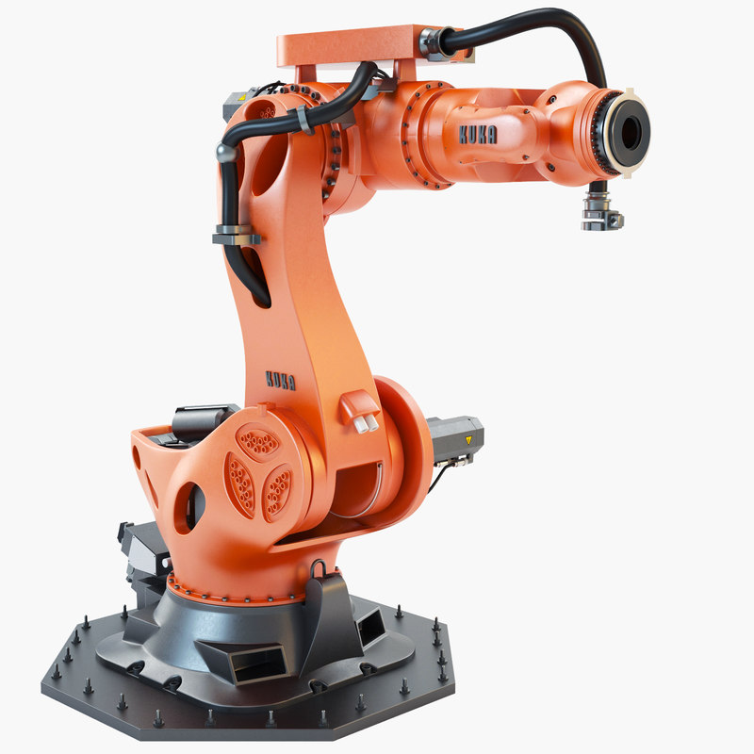





# Overview

This robotics package is intended to allow the user to create a robot of any configuration, using interactive GUI, and automatically calculate the following:

* Manipulator dynamics:

1. Finding Equations of Motion for a Manipulator Dynamics
2. Plotting Joint Position and Velocity

* Manipulator Controls:

1. Plotting Desired vs Actual end-effector position
   1. PD control with Gravity Compensation
   2. Inverse Dynamics Control

Assumptions:

The following assumptions should be made:

* All the joints are revolute or prismatic
* All the links are straight

Software used:

MATLAB version 2020a.

Peter Corke Robotic Toolbox version 9.10.

Team Contribution:

* GUI – Dallas
* DH parameters, kinematics – Kunal, Mehul, Dallas
* Dynamics – Kunal, Mehul, Dmitriy, Dallas
* Control – Mehul, Dallas, Kunal
* Documentation – Dmitriy, Kunal, Dallas

How to use the program

1. **Initialization – Robot base parameters**

First ensure that the user directory is open to the MAE 547 G10 Folder. This folder contains all files used t0 run the program.

Open MAE547_Root.m file and run this file.

Select **Initialization** tab then **Initial Conditions** to describe the robot

Input **Number of links**, then allow the program to fill in the initialization tables. Fill in the tables presented here, leaving any information not be considered in the simulation as zero. When choosing the Joint Limits the range is determined as a +/- value in degrees for revolute joints and the total range for prismatic joints.

For the Joint Limits, measure from the center position for Revolute Joints and the total range for Prismatic Joints.

Enter units in SI, angles in degrees.

Finally set the Degrees of Freedom options to 1 for each linear degree of freedom the robot has.

When finished press **Save Parameters** and Move on to the DH Tab

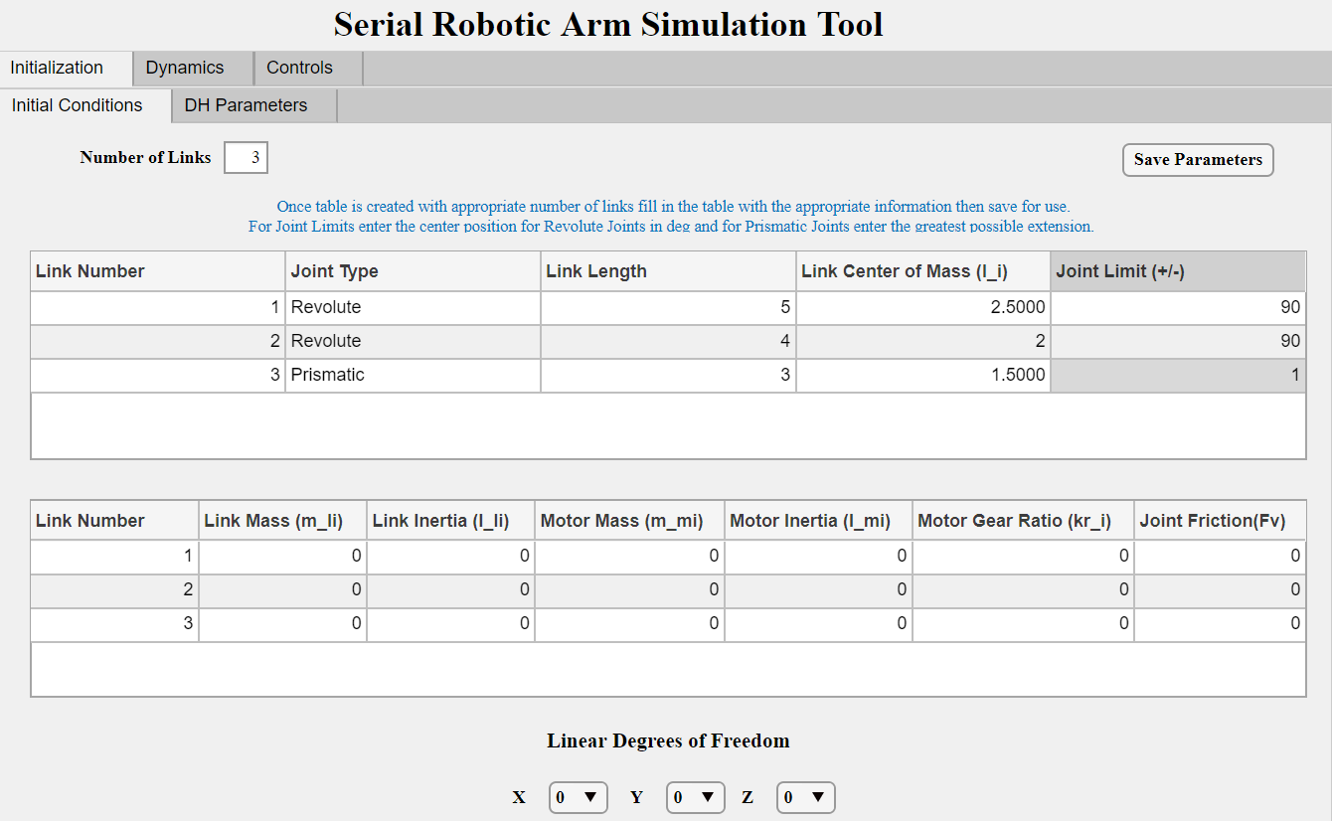 

1. **DH parameters**

Switch to **DH Parameters** tab. Depending on whether you know DH parameters or would like to calculate it automatically depending on robot configuration, choose either **Known DH Parameters** tab or **Find DH parameters.**

To find DH Parameters, click on **Find DH parameters** tab and choose direction of cosine Z-axis.

Next click on **Find DH Parameters** to complete the calculation.

Click on **Save DH Parameters** to finish.

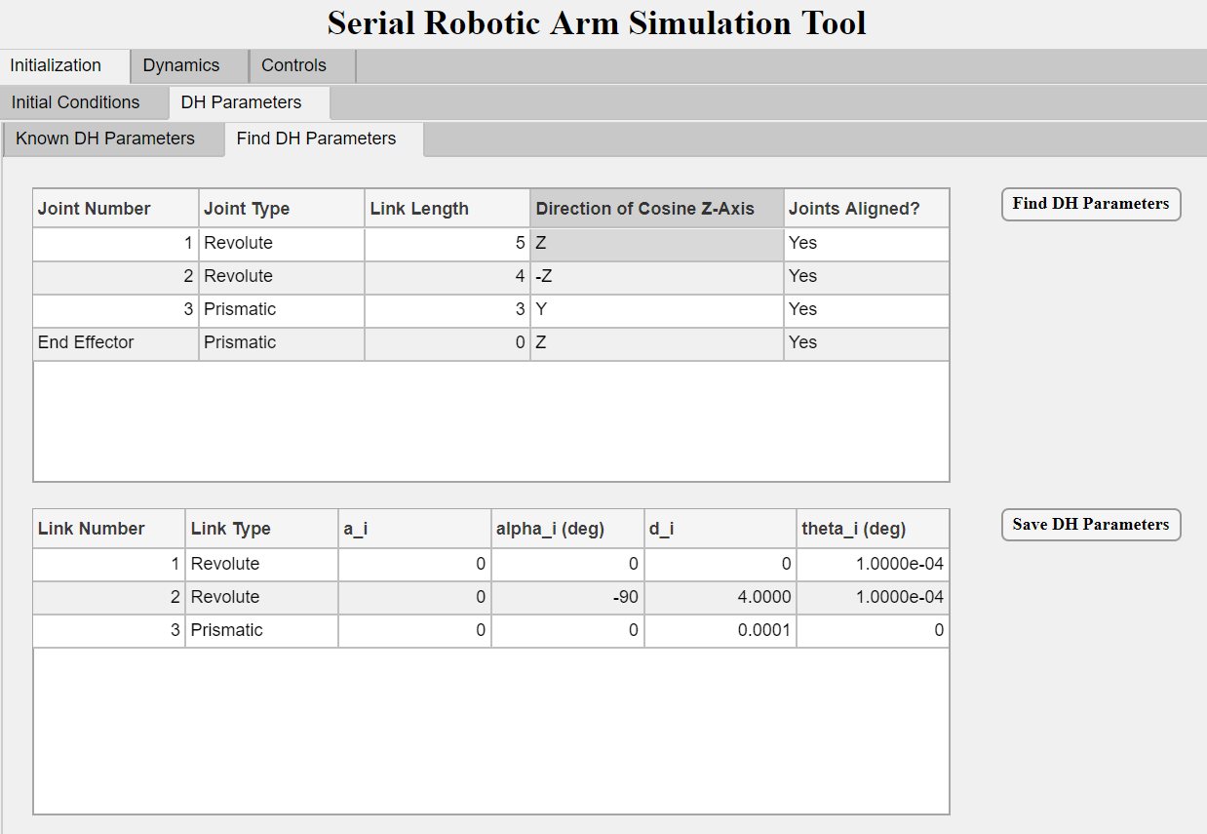

To enter known DH Parameters, click on **Known DH Parameters** tab and enter all parameters manually.

Click on **Save DH Parameters** to finish.

Either of the Save DH buttons will load the robot into the workspace, allowing for

simulations to be run. To change these parameters, the values from the Initial

Conditions can be altered and saved, but this will also repopulate the DH variables so

they will need to be re entered. This will bring up a graph of the robot in another

window. The default view is in 2D but to change the view just drag the screen to

adjust.

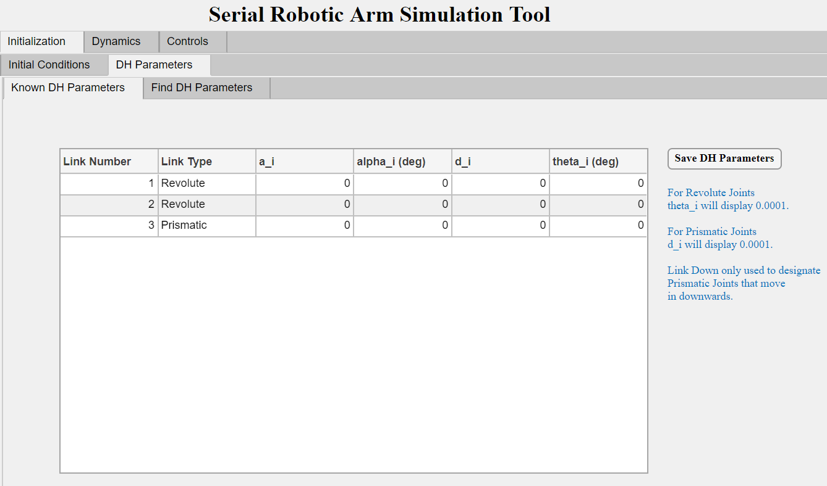

1. **Dynamics**

To calculate forward dynamics, choose the option **Forward Dynamics** and enter initial joint positions, velocities, desired joint torque.

Enter desired **Simulation Time** in seconds.

Next click on **Run Dynamics** and plots will be generated for **Joint Position**, **Joint velocity** or **Torque**.

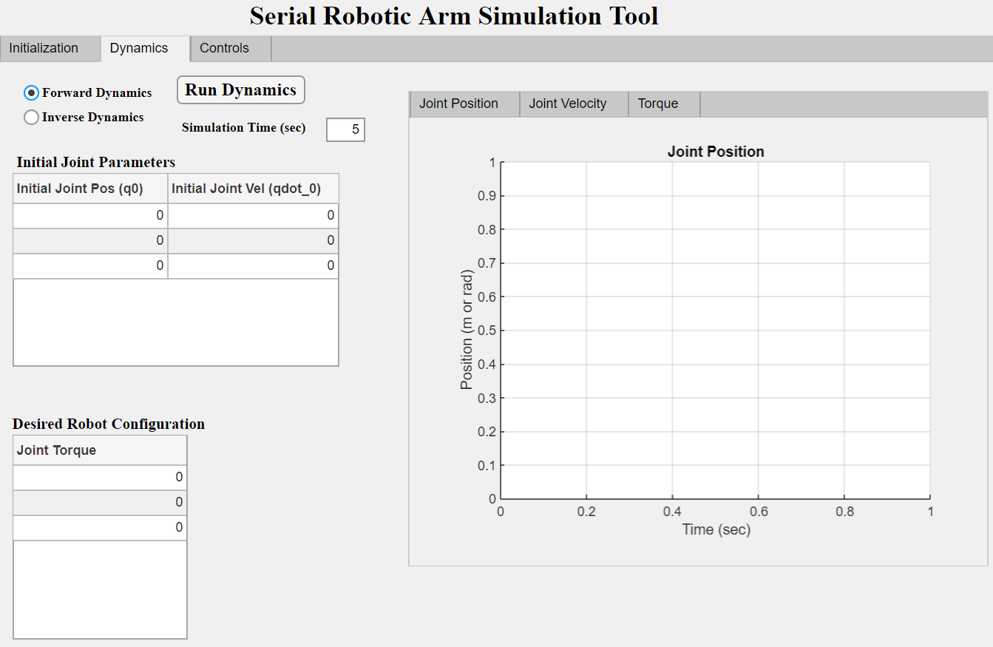

To calculate inverse dynamics, choose the option **Inverse Dynamics** and enter initial joint positions, velocities, desired joint position.

Enter desired **Simulation Time** in seconds.

Next click on **Run Dynamics** and choose from plot options for **Joint Position**, **Joint velocity** or **Torque**.

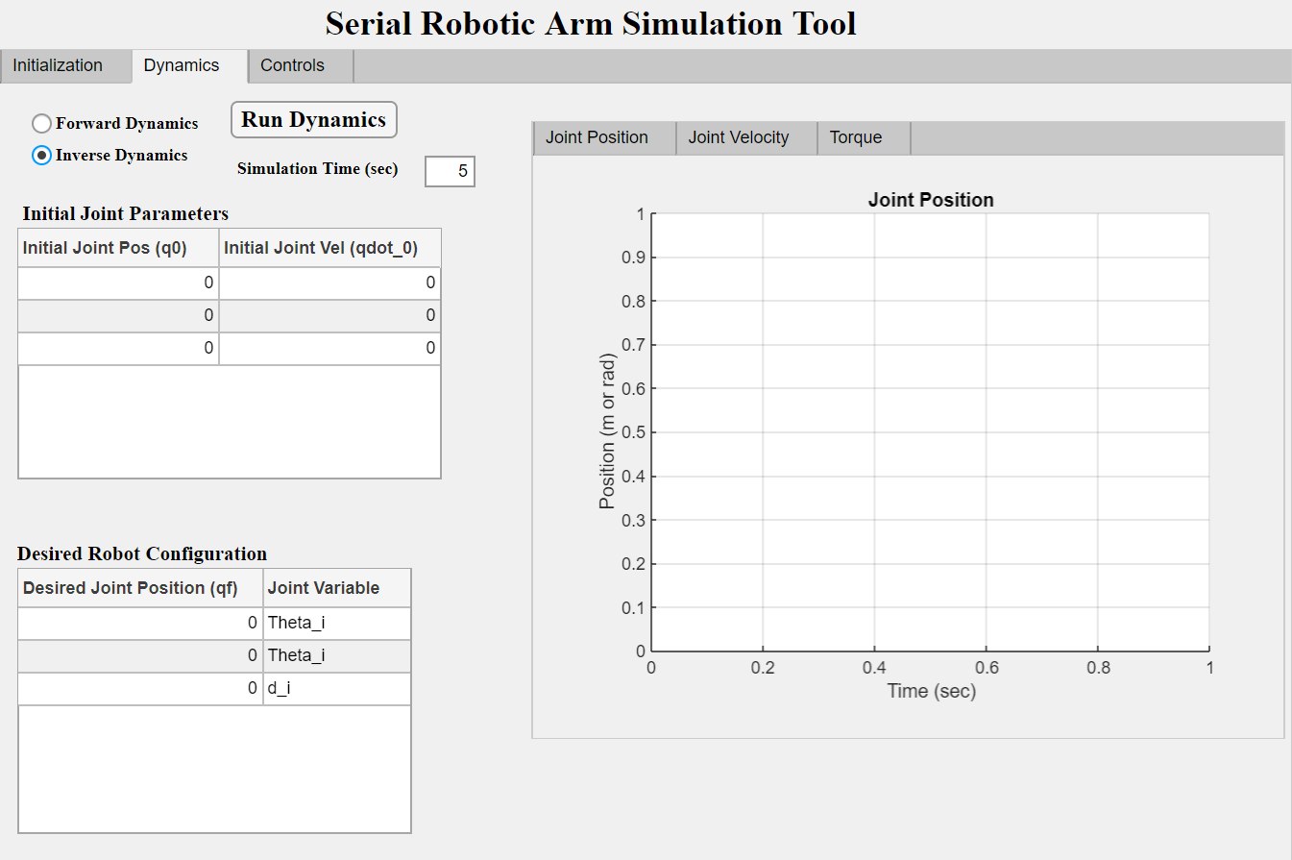

To find the general symbolic equations of motion for the robot you have chosen, click the **Symbolic Dynamics Equation** tab and

Set the **Axis of Gravity** option to the world axis that robot z coordinate lies on.

Then press **Formulate Symbolic Equations of Motion** and the equations of motion will be presented in the text box on the screen. The joint variables are expressed as q, qd, qdd for position, velocity, and acceleration respectively.

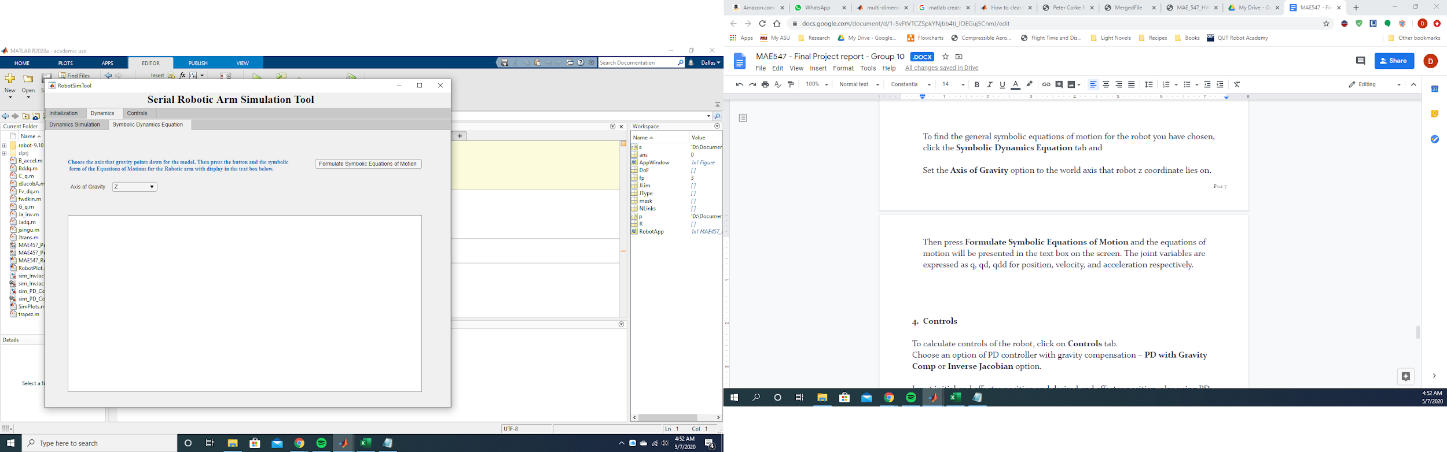

1. **Controls**

To calculate controls of the robot, click on **Controls** tab.

Choose an option of PD controller with gravity compensation – **PD with Gravity Comp** or **Inverse Jacobian** option.

Input initial end effector position and desired end effector position, also using PD controller – enter coefficients **Kp** and **Kd** for each link.

Enter desired **Simulation Time** in seconds and **Simulation Time Step** in seconds.

Click on **Run Controls**

This will open the simulink model for the control system you chose.

This will open the simulink model chosen. Press **Run** in simulink and the simulation

begin. If the scope icon is selected the position graphs will desplay in real time. If not,

the plots will be displayed in the GUI once finished.

If the simulation stalls it is likely that the position selected is out of the robots

workspace or has run into a singularity. In this case, break the simulation and input

new coordinates.

The given system can be changed at any time, just press **Run Controls** with the new

coordinates to set the new coordinate sets.

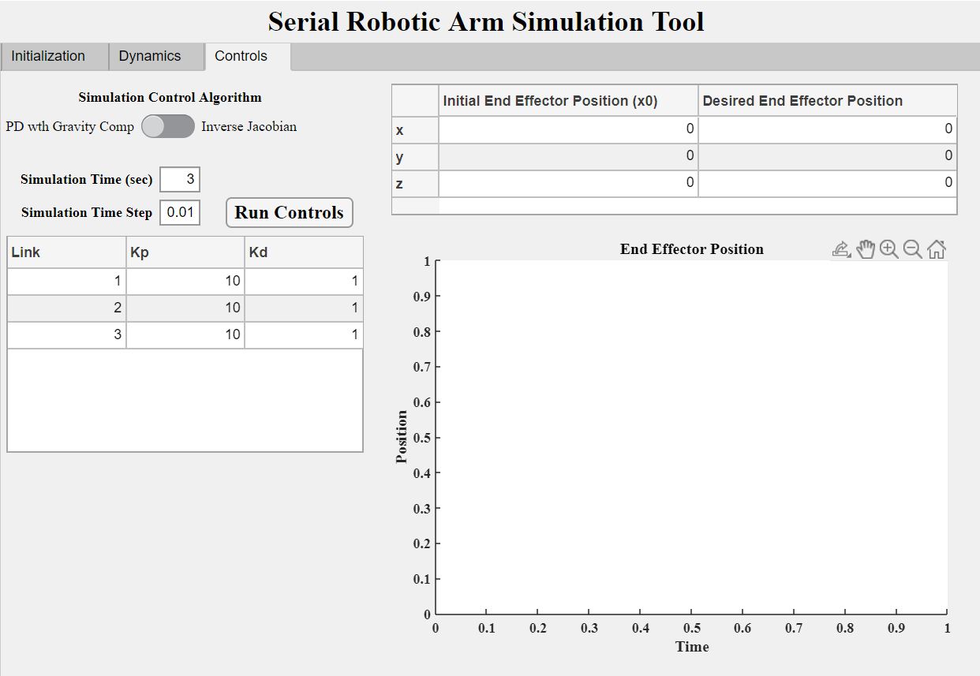

**References**

Codes used in program.

[1] Corke, P. I., Robotics, Vision & Control: Fundamental Algorithms in MATLAB, 2nd ed., Springer, 2017. ISBN 978-3-319- 54413-7.

[2] Siciliano, B., Sciavicco, L., Villani, L., and Oriolo, G., Robotics: Modelling, Planning and Control, Springer Publishing Company, Incorporated, 2010.

The toolbox was used extenively throughout